1. Write a program to reverse a word using loop?

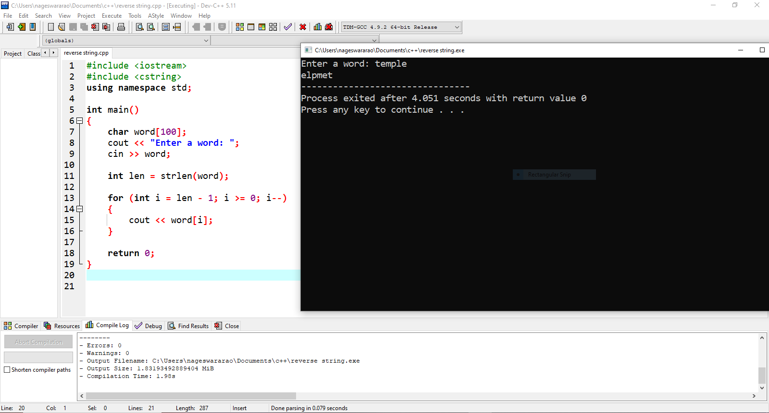

1. Write a program to print square star and rectangle dollar pattern? 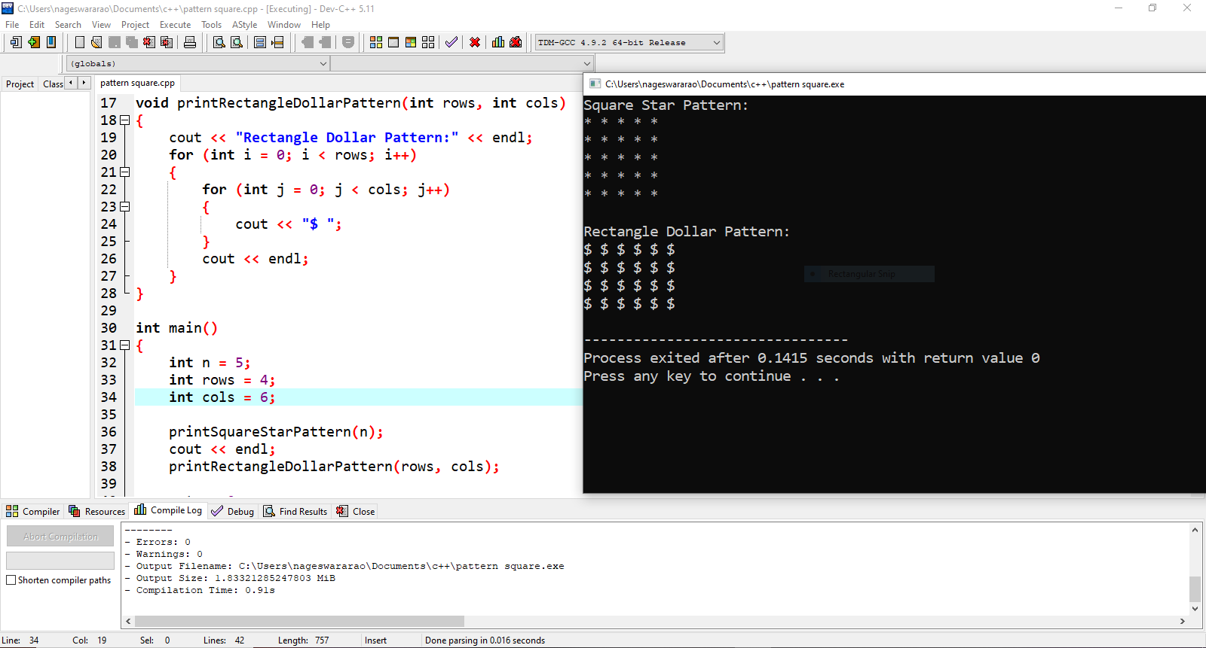

3. Write a program to count all the prime and composite numbers entered by the user. 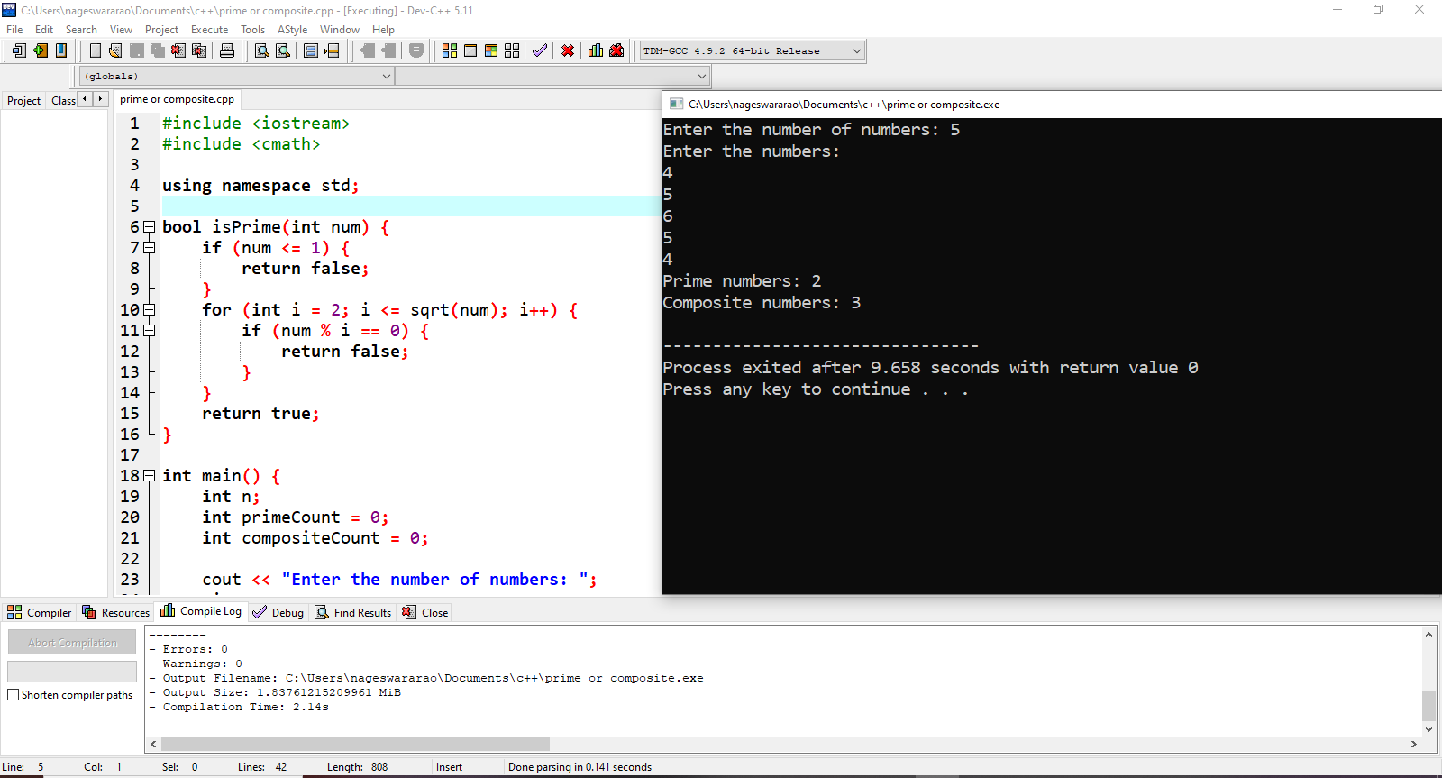

4 Write a program to check the entered user name is valid or not. Get both the inputs from the user.

